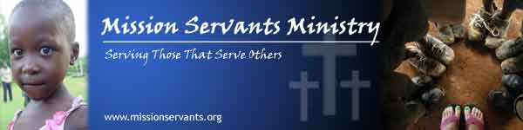
4001 Trehurst Ct., Charlotte, NC 28269 704-576-4646
RE: 2016 Mission Servants Ministry Year Summary January 18, 2017
Dear Child Sponsors, Supporters, and Prayer Warriors,

Thank you all so much for standing with Mission Servants Ministry during an incredible year of serving Jesus Christ and 100 kids. MSM is in its 10th year and 2016 was very eventful and we trust, divinely providential.
Trips. We made 2 large and extended trips in 2016 with 24 individuals to both the Lord’s Servants Home and Academy (LSH/LSA) in Kenya and the Stream of Hope (SOH) Home in Uganda and completed several significant projects as well as many smaller ones. The Girls Dorm was completed at SOH providing additional rooms and the ability to add children in 2017 as capacity has been increased from 40 to 60 children. Many smaller projects were completed to improve the playgrounds, facilities, and general conditions at the homes. The LSA now has the best playground in the region! It was the 4th year in a row of great year of capital accomplishments…Praise God.
Community Outreach. MSM continued to stand up for people in need in the communities. We completed a large Medical-Dental-Optical outreach for the Lyavo community near LSH in partnership with the Lyavo Bible Church. Local doctors and medicine brought from the U.S. were used to treat over 600 people, provide needed medicine, and share the love of Jesus Christ in a practical way. MSM also provided food and blessings to people local to Charlotte, NC in partnership with other churches and local agencies.
Growing Team. A 2nd social worker was hired at SOH Home to better manage the educational and health needs of our children and SOH was granted registration with the Government of Uganda. This was a significant accomplishment taking nearly 6 months. Very few Orphanage Homes have achieved this to date. This was a critical path for cooperation with the government and for adding additional children. .
We graduated 3 students from High School at LSH and SOH, all of which wish to continue their education. At both LSH and SOH, 7 more students will be entering High School which is an accomplishment, making the total number of kids in High School at 18. 10 others will be attending trade schools. Providing opportunities and encouragement so our kids can have a productive future is one of our main priorities.
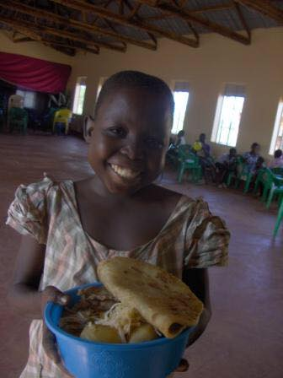
We did experience some heartbreak at SOH as two of those close to us went home to the Lord. Our Sister, Diana Nangobi, 15, fought complications from Sickle Cell Anemia all her life. Diana ultimately died because inadequate blood was available in the region for a needed transfusion. She has been at SOH for many years and although was too sick to go to school, she loved caring for the chickens at the home and being with her orphanage family. Always a positive loving girl who praised God joyfully, she is missed deeply. Survived by her Grandfather who lives in the community, Diana’s funeral was a tremendous celebration of her life and opportunity for many to hear of salvation through Jesus Christ. Roughly 500 people attended. Also, a dear Brother, Byakika, went home on Christmas Day after suffering terribly with cancer on his face. We stood with him through what treatments and medicines were available for over a year but they were begun too late to be effective. He loved the Lord and wanted to live longer to proclaim that. He is survived by a wife and young daughter.

Change at LSH. We have made a support and funding change. For 10 years, MSM has completely funded all operations and costs at LSH and LSA. God has blessed this with excellent facilities and a home that is now complete. MSM will continue to 100% fund all educational costs for all children through completion of High School or Trade School. The monthly sponsorships and donations are applied to this purpose. There are currently 14 children in High School and 31 children at our LSA. A second focus in 2017 is to supplement LSA revenue until it is self-sufficient, hopefully by year end. The school is growing, has over 150 students from pre-school to Grade 7, and is important to the community.
The balance of the budgetary needs for LSH and LSA will be supplied by the ministry of The Lord’s Ministires (TLM) in Kenya. Management will continue to be by TLM and its board of directors. MSM partnered with TLM in 2007 and praise God in all that was done. These changes we trust, are how we can best honor God and fulfill the MSM mission at LSH and LSA…
Our mission statement remains our roadmap…To honor God in all we do…To protect and serve our children to give them hope of reaching adulthood as productive members of society that know how to love others and know God loves them…To be a reflection of Jesus Christ to the community and a testimony to God’s Grace.

Thank you all again for standing with Mission Servants Ministry. We are making a difference in the lives of these children and the community. 100% of our support comes from monthly Child Sponsors and individual donors. We do not have any regular church, foundation, or grant support. We put our praise solidly in our Father and thank Him especially for opening hearts and bringing people to join. As always, 100% of our funds go to non-administration needs, projects, and child support. Our yearly financial 990 forms are available to view on the website.
Your 2016 donation statement is attached. You were part of less than $200,000 total donations in 2016 that allowed us to do all that was done through efficiency, volunteer service, and prayerful focus. We appreciate all you entrust to us. As Jesus commands, we are made to share the Good News. We believe that people will care about what we have to say when they know and see what we what we care about…exactly what our Father does…the least of these.
May God bless you big in 2017. We plan an exciting one for the kids at LSH and SOH with multiple trips and projects. Thank you again for your prayers and support!
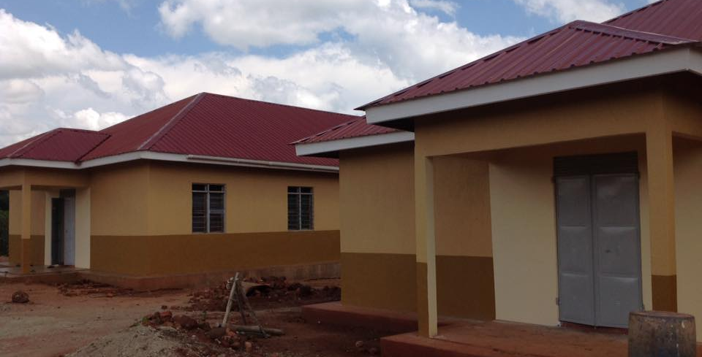
Bob Hillebrand, Director, Mission Servants Ministry
Please follow us by signing up at www.missionservants.org or liking Mission Servants Ministry on Facebook.
.

SOH Boys Dorm on left and new identical Girls Dorm on the right..Completed December, 2016

